Voice Chatbot development using chatterbot

Muhammad Nidzam Maso’od,

Ahmad Nizam Mohd Lazim,

Mohammad Nurihan Bin Salikin

Advance Informatics School (UTM AIS)

***Abstract* -** This paper presents a chatbot for helpdesk services. This chatbot was developed to offer communications assistants with users and inquiring new customer for the services. The chatbots is expected to increase customer experience, increase customer retention, reduce load to customer service call center basically for common asked questions and indirectly boosted their motivation. The chatbot is designed to be integrated in the company website in which may simplified the layout and text by only giving information that relates only to what customers are needed. Even though outside of business hour, it’s still able to facilitate and respond to the customer request such as product information, quotation for services, creating new profile or order and review current account.

***Keyword – Chatbot, Chatterbot,*** ***helpdesk services., customer experience, Natural Language Processing***

I. Introduction

This chatbot was developed to offer communications assistants with users and inquiring new customer for the services. The chatbots is expected to increase customer experience, increase customer retention, reduce load to customer service call center basically for common asked questions and indirectly boosted their motivation. The chatbot is designed to be integrated in the company website in which may simplified the layout and text by only giving information that relates only to what customers are needed. Even though outside of business hour, it’s still able to facilitate and respond to the customer request such as product information, quotation for services, creating new profile or order and review current account.

The objective of the speech recognition and chatbot service is to obtain the sequence of words spoken by the customer or speaker. The system should be able to understand every word and what are the meaning of each sentence. Then recognize the best answer as an output which should also been response in speech manner just like a conversation.

II. Literature review

In the paper from [1] explaining a framework which engage on statistical model based on Neural Network that learn historical conversation data up to latest conversation. Then the model will try to predict the meaning of the input request and to respond the best answer. In the framework proposed in Figure below, historical conversation data in dialog history database contain features of user information to suggest and recommend the appropriate respond based on specific user profile and the intention for each conversation. Information is flowing start from automatic speech recognition, interpreting the voice into words, identify the profile of user and try predicting the best answer in Dialog Manager.



Figure 1: Adaptive spoken dialog systems

While in the published article from [2], they are utilizing Deep Learning to develop a conversational support tools for clinicians. Historical data was recorded via survey with the respondents are selected from clinicians, based on the training data they were able to identify 32 categories on non-explanatory radiology skills for implementation in the chatbot. Watson Application Programming Interface (API) has been used to understand the input by implementing Natural Language Classier. The more input stored, and expansion of user will continually refine the abilities of it’s neural network to suggest and create new ideas for improvement.

In other research referred which presented by [3], they study on how the Chatbot should be able to responds to a question using the same language asked. New framework has been suggested which divides the question sentence into triples, combination of a noun, a particle, and a predicate. Experiment has been done using Japanese and clustering algorithm was applied to identify usage pattern and clustering the most frequent particle that have plural meaning. As the result, the framework able to answer 88% of input questions and 40% are valid answer.

III. VOICE CHATBOT FRAMEWORK

1. ChatterBOT

ChatterBot is a Python Library consists of function to generate automatic response to user’s input. This library uses a selection of machine learning algorithm to produce different types of responses [4].

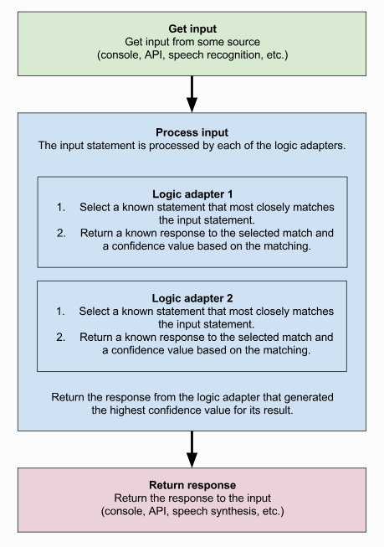

Figure 2 Process flow diagram for ChatterBot

The design of ChatterBots allows it to be trained to speak in any language and also the machine-learning nature allows it’s to improve the performance and accuracy.

ChatterBots starts with an untrained instance which have no knowledge on how to communicate. Each time a user enters a statement, the library saves the text that they entered and the text that the statement response to. The accuracy of each response will increase as it received more input statement and responses. The program will select the closest matching response by searching the closest matching know statement that matches the input, then it will choose a response from the selection of known responses to that statement.

For deployment, the ChatterBot can be easily integrated with Django.

1. TTS (TEXT TO SPEECH)

Text to Speech (TTS) is a process when given a text string, it will convert the text into speeches [5]. For python, there are a few libraries that can be used for this purpose. The list is as below;

1. Pyttsx

This wrapper can be used in cross platform and uses the speech engines based on the operating system. In order to use this wrapper, we need to install the pyttsx module. For python3 we need to install pyttsx3 module.

nsss - NSSpeechSynthesizer on Mac OS X 10.5 and higher

sapi5 - SAPI5 on Windows XP, Windows Vista, and (untested) Windows 7

espeak - eSpeak on any distro / platform that can host the shared library (e.g., Ubuntu / Fedora Linux)

1. gTTS

This module and command line utility to save spoken text to mp3 and uses Google Text to Speech (TTS) API. The API can be accessed by installing the gTTS module.

1. iOS TTS

This TTS is used inside an IOS operated system

1. Microsoft speech engine

This engine can be used by installing the module win32com and calling the module in the program.

1. IBM Watson TTS

IBM created its own TTS that can be access freely for a number of time. This API can support many languages such as English, German, Spanish, French, Italian, Japanese and Portuguese. This API can be accessed by installing the TtsWatson module.

For our chatbot, we will use pyttsx3 module as our TTS module.

1. SPEECH RECOGNITION

Speech recognition is a process to convert speeches into text or variable. This is the opposite function of TTS. In python there is as specific library for this purpose called PyPI [6]. In order to use this library, we need to install the SpeechRecognition module.

In this library, we have several speech recognition engine/API that we can use.

1. CMU Sphinx (works offline)
2. Google Speech Recognition
3. Google Cloud Speech API
4. Wit.ai
5. Microsoft Bing Voice Recognition
6. Houndify API
7. IBM Speech to Text
8. Snowboy Hotword Detection (works offline)

For our chatbot, we will be using Google API due to its accuracy.

1. Process FLOW

The process flow for our bot will be as below.

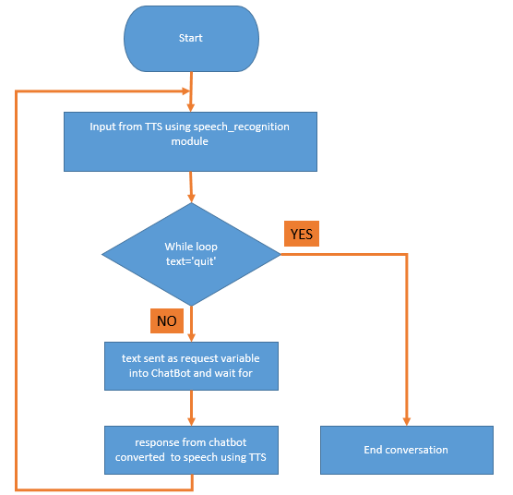

Figure 3 Process flow of Voice Chatbot

IV. APPLICATION USAGE

With the advance of Information Technology especially in Artificial Intelligence (AI), organization be able to gain better competitive advantage over their competitors if they adopt AI tools like chatbot as part of their business application.

In real world business application, chatbot has making big technology disruption in many business sectors, among those are in customer service management and sales representative. According to Business Insider, based on the recent trend and analysis, it’s been predicted that chatbots could replace 29% of customer service management and 36% of sales representative’s service sector in the United States alone, which in turn bring cost saving benefit of salary expenses at around $23 billion and $15 billion respectively [7].

By having chatbot for business application, the potential customers will be able to get instantaneous standard answer on their queries on products and services offering by the organization. Thus, reduce turnaround time for the customers support and reduce dependencies on the long waiting response time for the email.

It’s been proven in many business cases that swift response communication time with potential customers would result in better conversion rate as prospects are less likely to jump to a competitor. Chatbot can also assist to qualify potential customers by prompting back the right question to the prospect before automatically assigning the lead to respective sales representative. Thus, this will reduce time of sales representative on getting, instead just focusing on closing the sales from the assigned lead. Given all these benefits, it makes sense for the organization to delve into the details of deploying chatbots into their business dealing.

According to market research conducted by MindBrowser in 2017, most companies would want to place their chatbot on Facebook and their own website.

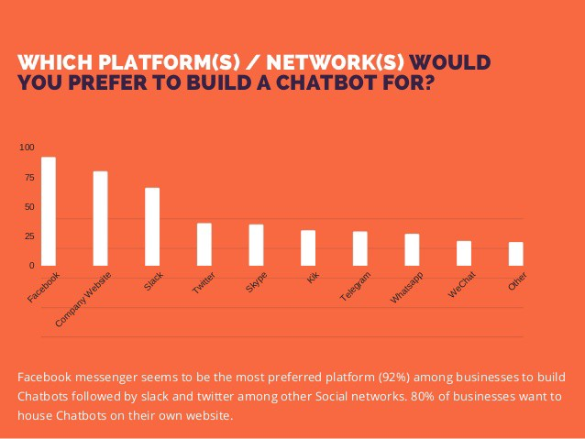

**Figure 4 Most Preferred platform for Chatbot application**

Meanwhile, survey by Oracle found out that 90% of businesses use Facebook to respond to service request and 65% of customers prefer to use a messaging app when contacting a business. Interestingly, 50% of customers would purchase items over a messaging app and over 50% of customers expect a business to be open 24-by-7. In term of return on investment, 56% feedback said engagement through messaging is ROI positive and 58% said by using the messaging reduce their business costs. The survey had also found that the main industries that would benefit most from chatbots would be e-commerce, insurance, healthcare, retail and hospitality [8].

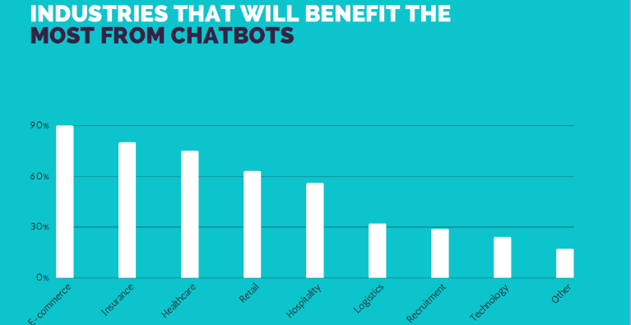

**Figure 5 Industries Benefit The Most From Chatbots**

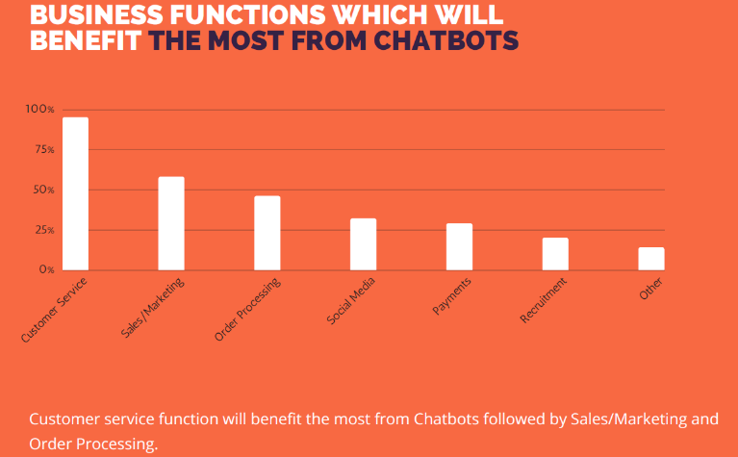

**Figure 6 Business Function Benefit The Most From Chatbots**

As we have mentioned earlier, Chatbots Application can be applied to many industries and business function areas. The following will discuss further on the specific Chatbot application across different business function. We will cover top 3 industries which are E-commerce, Insurance, and Healthcare

1. E-Commerce Industry

Offering ecommerce customers, a highly personalized experience of ecommerce site with the addition of a live chatbot can help guide consumers down the sales funnel, and ultimately influence their buying decisions. Chatbots can act as an encyclopedia of product knowledge, providing support to customers who have questions or hesitations on the way to the checkout page.

Further, they can also be programmed to take data from email marketing campaigns, upsell and cross-sell products, offer discounts codes and so on, much like a store concierge. From each interaction with a customer, the program will continue to learn from these past experiences, providing higher quality customer interactions over time.

As well as interacting with customers, live chatbots can be programmed to keep track of store inventory, update store owner and the customers know that the store may be out of a particular item in the online store. Similarly, they can also be programmed to let a customer know that the product they were looking for has arrived back in stock. As a benefit to business operations, chatbots provide a helping hand, saving organization time and effort in managing their ecommerce store.

Live chat apps can provide a cheaper alternative to help store owner cut down on team numbers and provide an excellent service to customers by tracking customer contact histories and providing people with immediate, non-urgent support. In some cases, this can be sufficient to fulfill their needs. For example, a chatbot can easily drive a conversation about returns and product exchange policy. Also, for companies trading overseas, the use of chatbots in customer service can prove very useful in helping the storeowner get around difficulties such as language barriers [9].

1. Insurance Industry

Currently, chatbots in the Insurance industry play a dual role. First, they are an extension of the customer service contingency, assisting customers with standard queries & menial tasks with utmost precision & clarity. Secondly, they act as smart assistants to actual agents, making their lives easier.

When integrated with mobile messaging apps, chatbots can act as virtual customer service representatives, engaging with prospective customers using natural language, answering basic questions and assisting them in determining which insurance products would be most appropriate for their needs.

The traditional method requires insurance agents to invest considerable amount of time and effort in closing the deal. A chatbot, on the other hand, can communicate simple information and handle common doubts with multiple prospects at the same time. This allows customer executives to redirect their effort where it is most required handling complex issues and closing the deal.

One of the common use case for chatbot in insurance is improving customers experiences. As more and more people engage in messaging platform, chatbot is basically leveraging this existing platform for example Facebook Messenger and Telegram to serve new and existing customers. Gone are the day, where customers have to listen to long conversational advice from insurance agents. Insurance chatbot will helps customers sift through policy options based on their risk profile and coverage needs, and recommends the appropriate product.

In term of personalization, with every interaction, the insurance chatbot continues to collect a wealth of information pertaining to the customer. Therefore, each time, the exchange becomes a bit more personal. This in turn can help insurance chatbots learn more about ‘conversation’ & get better at solving specific customer problems.

In term of functionality, essentially, insurance chatbots can help both the customer & employee navigate through a sea of data. They are capable of deconstructing & selling complex products, driving adequate engagement, & solving customer queries to a certain extent without manual intervention.

In term of profitability, to begin with, they are enabled by the messaging culture. They can instantly be deployed onto all messaging platforms, reaching billions of users on WhatsApp, Telegram, FB messenger etc. Next, they reduce costs. Gone are the days you had to outsource customer service to call centers. The insurance chatbot will take care of it now. And last but not least, it is accessible to the customer around the clock. They can use it when & where they see fit [10].

1. Healthcare Industry

The use of online Chatbots for healthcare on a medical practice’s website can drastically increase its client engagement levels, while costing a mere fraction of the conventional method. People are already online, searching their symptoms on Google. Clinics and hospitals can attract these people to their websites and start a conversation with them via chat. The chatbot scripts can include symptom checking questionnaires, which patients can use to understand their symptoms better. The medical chatbot can then offer these patients access to treatment at the clinic or hospital, by instantly scheduling appointments through the chat window itself. Because this interaction does not depend on business hours or working days, and can happen right through the patient’s computer or smartphone, it can quickly lead to a full calendar of appointments for the clinic in question.

Another example in healthcare of chatbot application is for patient diagnosis, with the use of AI and machine learning and combine with algorithms trained on large volumes of clinical content, such as medical protocols and chronic disease information, to interpret patient symptoms and to recommend an appropriate diagnosis. For example, users enter their symptoms via using speech, text, images and video, can view a list of related conditions and through a series of prompts the virtual assistant can identify a patient’s potential condition [11].

Other than clinics and hospitals, pharmacies can also use chatbot as an inexpensive and efficient networking tool. People spend a lot of time online, looking for information on the drugs they’ve been prescribed. By establishing themselves as credible sources of information on specific drugs and medications, pharmacies   and even hospitals with in-house drug stores   can engage more patients. The best way to do this is to create a chatbot that is programmed to answer common questions on drugs, their composition, indications, recommended dosages, side-effects, and so on. These FAQs can complement any other tasks that the medical chatbot is already performing, such as scheduling appointments or matching patients with doctors in the local area.

In other healthcare related area, medical equipment manufacturers can also create a chatbot to answer these questions, thus reducing the number of customer support calls they have to answer, or the amount of marketing they need to do. In the process, they save time and resources, both of which they can use to scale up their business.

VI. SUMMARY

Advent in Artificial Intelligent technologies have come so far that helps mankind manipulate and leverage existing systems and move forward to provide better solution for current and future generation. This paper has discussed on some of the chatbot technologies used in different industries and business function. Various chatbot framework has been discussed in detail by comparing which is the best suite to different need based on different requirement and environment, among others are Chatterbot, Text-To-Speech, and Voice Recognition. In this paper we have outline necessary steps and process for each framework to suite to our requirement for the development of voice chatbot using chatterbot.

The main highlight are the multiple use cases within the same industry and how it benefits the organization by using the chatbot application. Top 3 industry benefit the most from chatbot application are E-commerce, Insurance and Healthcare. And as highlighted above, the most beneficial business function of chatbot application is from customer services follow by sales and marketing and sales order.

Huge cost saving benefits are identified in the E-commerce industry by cutting down the number of sales and marketing team, customer service team, and operation team. Where else, in the Healthcare industry it helps a lot in reducing the turnaround time for patients getting the right medical advices and diagnosis prior to medical appointment with the specialist. The same goes to the Insurance industry, whereby time and resources will reduce further with the assistance of chatbot, further cost reduction when the company no longer require to outsource to call center for customer support, and by leveraging existing messaging platform, company can instantly create chatbot application which already come with billions of potential customers [12].

# References

|  |  |
| --- | --- |
| [1] | D. Griol, J. M. Molina and ZoraidaCallejas, "A proposal for the development of adaptive spoken interfaces to access the Web," *Neurocomputing,* no. 163, pp. 56-68, 2015. |
| [2] | K. F. Seals, J. Hedge and R. Suh, "Utilizing Deep Learning to Develop a Conversational Support Tool for Clinicians: Creating a Radiology Chatbot," *SIIM 2017,* 2017. |
| [3] | M. Kimuraa, "A proposal of topic map based Chatterbot for non-English natural language input," *International Conference on Knowledge Based and Intelligent Information and Engineering,* no. 19, p. 841 – 849, 2015. |
| [4] | "Python," [Online]. Available: https://pythonprogramminglanguage.com/text-to-speech/. |
| [5] | "ChatterBot," 2018. [Online]. Available: http://chatterbot.readthedocs.io. |
| [6] | "SpeechRecognition 3.8.1," 5 Dec 2017. [Online]. Available: https://pypi.org/project/SpeechRecognition/. |
| [7] | "Chatbot revenue is on the upswing," 29 Mar 2017. [Online]. Available: http://www.businessinsider.com/chatbot-revenue-is-on-the-upswing-2017-3/?IR=T. |
| [8] | "Chatbot Application Survey," 2017. [Online]. Available: http://www.oracle.com/us/technologies/mobile/chatbot-infographic-3672253.pdf. |
| [9] | "5 Awesome Use Cases of Chatbots in Ecommerce," 15 Aug 2017. [Online]. Available: https://www.livechatinc.com/blog/use-cases-chatbots-ecommerce/. |
| [10] | "Chatbots In Insurance: A Smart Way To Save Costs, Enhance Customer Service & Increase ROI," Jan 2018. [Online]. Available: https://chatbotslife.com/chatbots-in-insurance-a-smart-way-to-save-costs-enhance-customer-service-increase-roi-f03c1b788138. |
| [11] | "Chatbots for Healthcare – Comparing 5 Current Applications," Mar 14 2018. [Online]. Available: https://www.techemergence.com/chatbots-for-healthcare-comparison/. |
| [12] | "How chatbots are transforming insurance – eight examples," 29 Aug 2017. [Online]. Available: https://insuranceblog.accenture.com/how-chatbots-are-transforming-insurance-eight-examples. |